Azure Front Door
https://www.youtube.com/watch?v=XVR_p2wx6XI
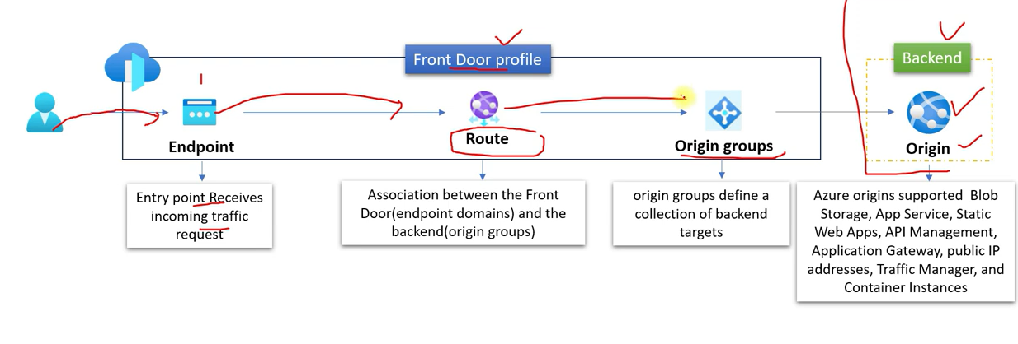
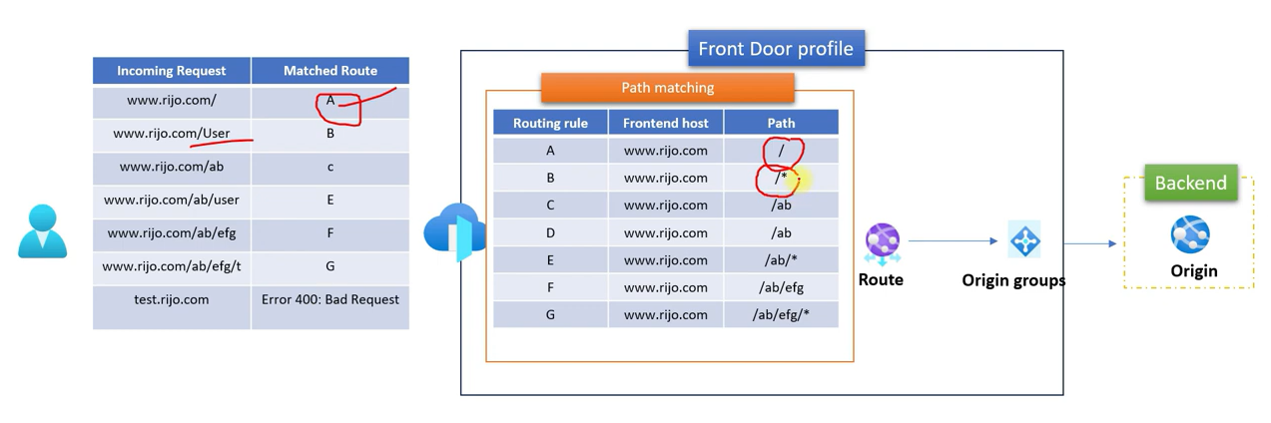
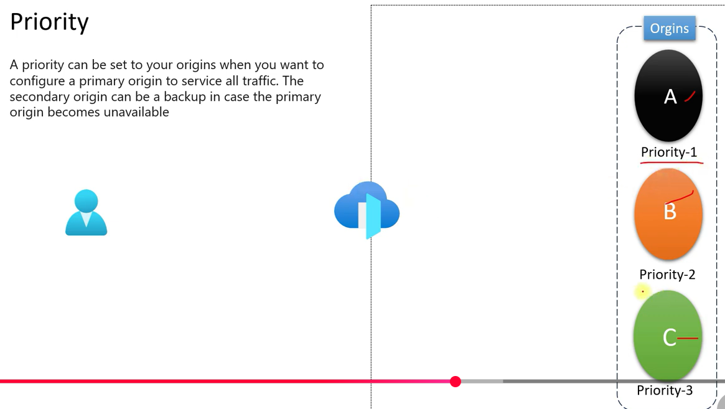
With same priority , distribution will be based on the weight also on latency

